**FRESHCO HYPERMARKET CAPSTONE**

**PROJECT REPORT**

**Introduction:**

The following report presents a comprehensive analysis of the Freshco Hypermarket Database. The analysis is divided into four main sections, each focusing on different aspects of the data to extract valuable insights and answer specific questions. The four sections are as follows: Order-level analysis, Completion Rate analysis, Customer-level analysis, and Delivery Analysis.

**Order-level Analysis:**

* Analysed the distribution of orders across delivery slots and delivery areas to understand demand patterns.
* Identified areas with the highest increase in monthly orders from January to September, highlighting regions experiencing significant growth.
* Calculated delivery charges and discounts as percentages of product amounts at the slot and month level to assess their impact on order value.
* Determined the discount as a percentage of the product amount, considering both drop areas and delivery slots.

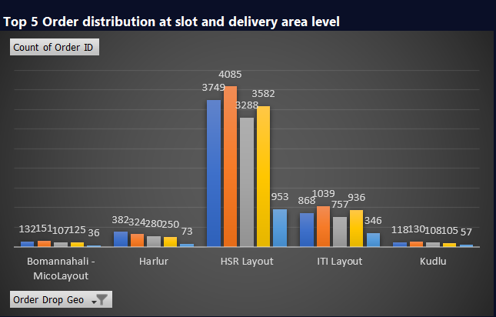

HSR Layout, has the highest count of Orders, during **Afternoon** Time-Slot.

**Completion Rate Analysis:**

* Explored completion rates in relation to delivery slots and days of the week to identify any patterns or trends. This information can guide scheduling and resource allocation decisions.
* Calculated completion rates at the drop area level to assess the efficiency of deliveries in different regions. This analysis can inform logistics and delivery optimization strategies.
* Analysed completion rates based on the number of products ordered in each transaction. This insight helps in understanding customer behaviour and preferences.
* Provided detailed insights into any patterns observed in the completion rate data. Understanding these patterns can lead to actionable strategies for improving order fulfilment and customer satisfaction.

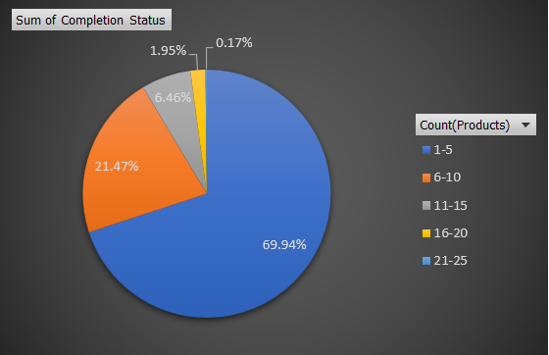

Count of 1-5 Products ordered having the **highest** percentage of Orders Completed.

**Customer-level Analysis:**

* Identified completion rates based on customer acquisition sources, shedding light on the performance of different acquisition channels. This information is vital for optimizing marketing efforts.
* Calculated the Customer Lifetime Value (LTV) for individual customers, enabling a deeper understanding of long-term customer profitability.
* Aggregated LTV data to assess the overall performance of customer acquisition sources and acquisition months. This analysis helps in resource allocation and marketing strategy refinement.
* Determined the average revenue (product amount after discount) per order at different customer acquisition source and acquisition month levels. This information is essential for pricing and promotional decisions.
* Explored potential patterns in order ratings concerning various factors such as delivery slots, the number of items ordered, delivery charges, and discounts. These insights can inform service improvement initiatives.

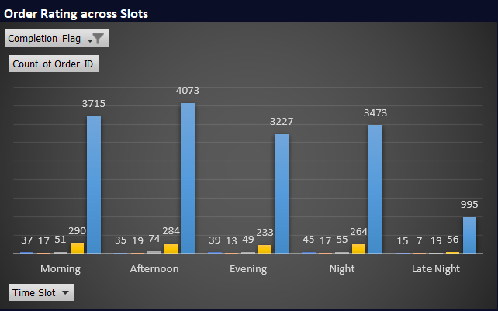

Afternoon Time Slot, having the **highest** number of 5-Star Rating (4073).

**Delivery Analysis:**

* Calculated the average overall delivery time at the month and delivery area levels. This analysis provides insights into delivery efficiency and customer expectations.
* Analysed delivery times categorized by weekdays and weekends, allowing for a comparison of delivery performance during different times of the week.
* Assessed the average delivery time by delivery slot, which is crucial for optimizing delivery logistics and meeting customer expectations.
* Examined patterns in delivery charges concerning delivery slots and delivery areas. Understanding these patterns can guide pricing strategies.
* Investigated patterns in delivery times concerning specific delivery areas and identified any potential reasons for variations. This analysis helps in optimizing delivery routes and reducing delivery times.

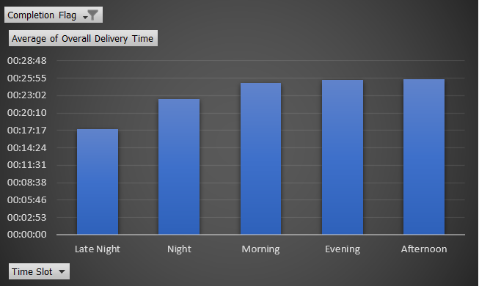

Late Night Time Slot, having the **least** amount of Delivery time, due to the less amount of traffic and other factors.

**CONCLUSION**

The detailed analysis of the Freshco Hypermarket Database has provided valuable insights into various aspects of the business, including order distribution, completion rates, customer behaviour, and delivery efficiency. These insights are instrumental in making data-driven decisions and implementing strategies for improving overall performance. Based on the findings, I recommend implementing targeted strategies to address observed patterns and enhance customer satisfaction, delivery efficiency, and order completion rates. Continuously monitoring and analysing data is essential to adapt to changing market conditions and customer preferences effectively.

Santosh Prasad D